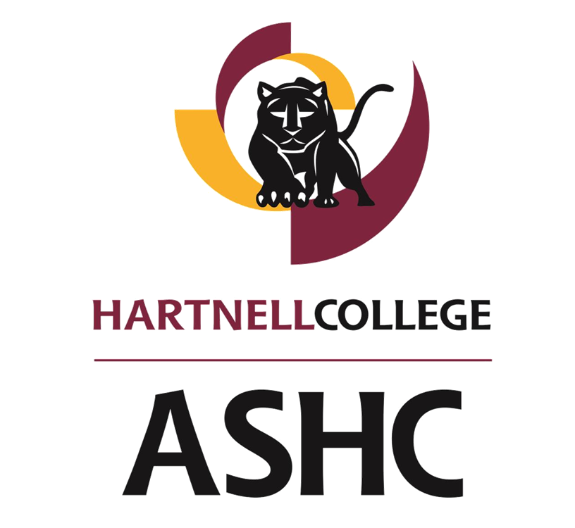 | Location  Hartnell College  411 Central Ave  Salinas, CA 93901  Building C, Room 101 | Date and Time  Thursday, 03/05 /20, 3:00 pm
“Fostering the Panthers of today, to become the scholars of tomorrow.”
ASHC Minutes

NOTICE IS HEREBY GIVEN that the ASHC will hold a meeting on the above stated date and time. If you have any questions please contact Secretary ”Cali“ Robert Rendon, at Robertgrendon@student.hartnell.edu or Selso Ruiz, Program Assistant at Sruiz@Hartnell.edu.
IF YOU HAVE A DISABILITY please contact the ASHC by Monday before the upcoming meeting so that we may accommodate you.

- ORGANIZATIONAL ITEMS 3:17
1.01

1.02 Roll Call P=Present A=Absent

President Saldana __P__  Vice President Polo __P__  Secretary Rendon __P__  Treasurer Sorto __P__  Director ICC Ehlers _P___  Senator Alaniz __L__ 3:30  Senator Verdin _P___  Senator Gloria __P__  Senator Alisal Campus Cisneros-A. __A_ | Senator South County Lamas __P___  Director P&S Flores __EA__  Senator Online/Eve/Wknds Castillon __P__  Director PR Crespo _P___  Senator Macias Reyes __P__  Senator Salazar-Salas _EA__  Advisor Ruiz __P__  Advisor Nevarez __P__
1.03 Adoption of Minutes:

II. PUBLIC COMMENT
This time is reserved for members of the public to address the ASHC.
All public comments are limited to three (3) minutes. No action will be taken on these items unless it is scheduled. Please note once public comments are closed, members from the public will only be recognized at the Chair’s discretion. Furthermore, the members of the ASHC cannot respond to any public comments.

III. Old Business :

3.01 Legacy project Legacy Committee Action(5min)
The ASHC Legacy Project committee will update and discuss the finishing date for the downshift room.
- The legacy project will have a meeting with Joseph in order to have everything figured out with for the timeline and room.
- The legacy committee will work on the legacy project and take it easy for the elections.
- work will start after the meeting with Joseph.

3.02 Ag knowledge Program Ag Knowledge Committee Discussion(5min)
This Item is to update and discuss the next step from the AgKnowledge Committee Nicole, Angelita, Evelyn and Daniel.
- There are no further updates for the Ag Knowledge Program.

3.03 ASHC Elections President Saldana Discussion(10min)
This item is to discuss plans for the Fall and Spring semesters of 2020-2021 ASHC elections.
- We must prep and prime students who might seek interest to run for a position for the ASHC.
- Elections Outreach Committee
  - Aixa, Remel, Polo, Evalyn
  - Canvas is an option to reach the students
  - Athletes Flyer can be made to join the ASHC
  - In the flyer to add time and date,
  - Updates will be presented on the of March 26th due to Spring break
- Elections Video Committee
  - Sam, Cali, Britany, Angelita
- Pros of elections
  - meeting the candidate “passport”
  - burritos
- Cons of elections
  - Tabling were inefficient

3.04 ASHC Movie Project President Saldana Discussion(10min)
This item is to discuss the plans for the movie to promote the ASHC council for Fall and Spring semester of 2020-2021.
- We are looking for students to be in a video presented to promote the ASHC.

IV. New Business:

4.01 Centennial Celebrations President Saldana Informational(10min)
This item is to receive information on the Centennial Celebration plan.
- The centennial celebration
  - Volunteer students for the centennial
  - March, April, and May, working with the food bank to accumulate 100 hours of community service to the monterey county food bank
  - 730am-4:30 pm to help serve on Tuesday’s and Thursday’s
  - contact of information astodard@hartnell.edu
- On June 20th, there will be an alumni celebration.
  - They would like help with registration, set up, and other activities.
- June 21st, Big Community celebration for the centennial
  - They are seeking volunteers
- Centennial meetings take place every 3rd Thursday, at 12pm, in room E-112.

4.02 Panetta Lecture Series President Saldana Informational(10min)
This Item is to invite ASHC Officers to the Panetta Institute Lecture Series.
- March 16th, 12:45pm-4:30pm, 2020 Leon Panetta Lecture Series
- This will allow students to sit in the crowd.
- 12:45pm-4:30pm.

4.02 SSCCC Update Senator Castillon Informational(10min)
This item is to give an update on what was discussed at the SSCCC meeting that took place over the weekend.
- The March in March will be taking place
- There will be a meeting Next Friday 13th, there will be another meeting in El Gabilan.
- We would like to host a SSCCC meeting here at the Hartnell Campus.
- Meetings are on Friday, starting at 5:00pm-9:00pm. We would like to Host in May
- The first assembly is in April.
- In the next development meeting, SSCCC resolutions will be discussed.

V. ASHC/GOVERNANCE REPORTS
- Academic Affairs Council
- Accreditation Council
- Administrative Services Council
- Advancement Council
- Student Affairs Council
- Technology Development Council
- College Planning Council
- Student Trustee
- ICC Report
- Student Success Committee
- Diversity Committee
- Appointment Committee
VI. ANNOUNCEMENTS
Womens Empowerment Conference
- Augiustine will be needing help in the kitchen.
- If helping in the kitchen, wear all black, cover all skin for protection.
- The Fashion Show needs 5 Volunteers
- Be Present on Friday for preparation and set up from 3:30pm-5:00pm.
  - There will be an event on Friday 3/13
- Dress Professional for the conference
VII. ADJOURNMENT 4:29

