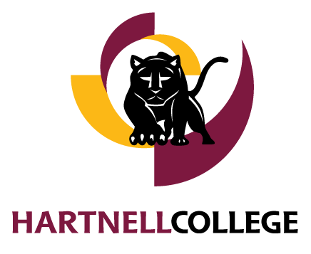

HARTNELL COLLEGE

POSITION DESCRIPTION QUESTIONNAIRE

Manager/Supervisor Supplement

Please carefully review the completed employee Position Description Questionnaire (PDQ) and be sure that it gives a complete and accurate picture of the employee’s responsibilities, job requirements and working conditions.

Do not edit, modify or change the employee’s questionnaire. Since this is not a performance review, do not make comments about employee performance.

All completed employee PDQs and Manager/Supervisor Supplements must be delivered to Human Resources by close of business on September 21, 2022.

IMMEDIATE MANAGER’S OR SUPERVISOR’S REVIEW
Name & Class Title of Employee Completing PDQ:
Name & Title of Supervisor Completing Supplement:
Do you agree the employee’s questionnaire provides a complete and accurate description of the job?
Yes No If no, please explain or amplify.

In your words, what is the primary function or purpose of this job in relation to the mission, goals and objectives of the department or division?

What do you consider this position’s most important responsibility or performance result?

Are there any other certifications, licenses or special training that are essential for performing the duties of this position(s), beyond those listed by the employee(s)? If yes, please list below. Are any of the certifications, licenses or special training listed by the employee(s) desirable, but not mandatory?

Describe briefly the three most important knowledges and skills you believe are necessary for successful job performance.

Are you aware of employees in other classifications performing work very similar to this position? If yes, please list these employees and class titles.

Do you believe this position is in the right job classification? Yes No If No, what are your reasons and what classification do you believe would be more appropriate?

Other comments.

Manager or Supervisor Signature Date ___________________________

